

VOLUNTARY NON-REMUNERATED BLOOD DONATION

DETAIL DESIGN DOCUMENT

Class Design

**Project Code: VNBD**

**Document Code: VNBD_Class Design_v1.0_EN**

**Ha Noi, 12/10/2013**

Record of change

*A - Added M - Modified D – Deleted

|  |  |  |  |  |
| --- | --- | --- | --- | --- |
| Effective Date | Changed Items | A* M, D | Change Description | New Version |
| 01/10/2013 | Add new | A |  | v0.1 |
| 12/10/2013 | Modify | M | Update comments of supervisor | v0.9 |
| 20/10/2013 | Modify | M | Update comments of supervisor | v0.9.9 |
| 23/10/2013 | Modify | M | Update version | v1.0 |
|  |  |  |  |  |
|  |  |  |  |  |
|  |  |  |  |  |
|  |  |  |  |  |
|  |  |  |  |  |
|  |  |  |  |  |
|  |  |  |  |  |
|  |  |  |  |  |

SIGNATURE PAGE

**ORIGINATOR:** Nguyen Manh Cuong 12/10/2013

Developer

**REVIEWERS:** Nguyen Thi Tam 13/10/2013

Tester

Ngo Tran Linh 13/10/2013

PM

**APPROVAL:** Bui Dinh Chien 23/10/2013

Supervisor

TABLE OF CONTENTS

1 Introduction 5

1.1 Purpose 5

1.2 Definitions, Acronyms and Abbreviations 5

2 Packages 6

2.1 User Package 6

2.1.1 Class diagram 6

2.1.2 Model_User class 7

2.1.3 UserController class 8

2.2 Post Package 9

2.2.1 Class diagram 9

2.2.2 Model_Post class 10

2.2.3 PostController class 11

2.3 Qa Package 12

2.3.1 Class diagram 12

2.3.2 Model_Qa class 12

2.3.3 QaController class 13

2.4 Comment Package 14

2.4.1 Class diagram 14

2.4.2 Model_Comment class 15

2.4.3 CommentController class 15

2.5 Admin Package 16

2.5.1 Class diagram 16

2.5.2 Model_User class 17

2.5.3 Model_Post class 18

2.5.4 Model_Qa class 19

2.5.5 Model_Comment class 20

2.5.6 AdminController class 20

3 Data access object and mVC model 22

# Introduction

## Purpose

Voluntary non-remunerated blood donation class design document contains descriptions of all classes of the Voluntary non-remunerated blood donation system. It includes:

* Class diagrams that describe the static relation of all classes in the system.

## Definitions, Acronyms and Abbreviations

|  |  |  |
| --- | --- | --- |
| Abbreviations | Description | Comment |
| MVC | Model View Control model |  |
| D.A.O | Data Access Object |  |

# Packages

|  |  |  |  |
| --- | --- | --- | --- |
| No | Package | Language | Description |
| 1. 01 | User | PHP | Store all information of User, or perform register, reset password. |
|  | Post | PHP | Store news or search text in post. |
|  | Comment | PHP | Comment of Users. |
|  | QA | PHP | Q&A of Users and answer Q&A. |
|  | Admin | PHP | Manage User, post, Q&A, comment. |

## User Package

### Class diagram

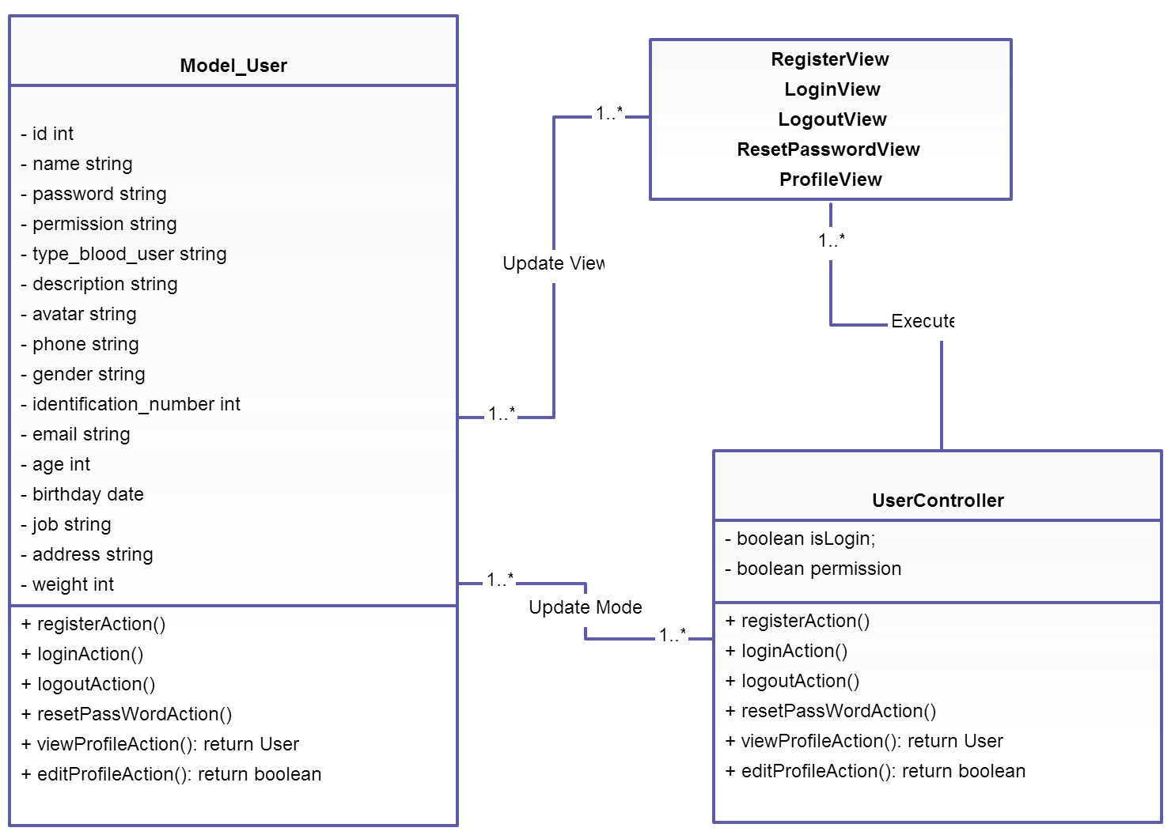

**Figure 1: Class diagram user package**

|  |  |  |
| --- | --- | --- |
| No | Class Name | Description |
| 1 | Model_User |  |
| 2 | UserController |  |

### Model_User class

#### Attributes

|  |  |  |  |  |  |
| --- | --- | --- | --- | --- | --- |
| No | Attribute | Type | Default | Note | Description |
| 1. 1 | Id | Int |  | private |  |
|  | Name | String |  | private |  |
|  | Password | String |  | Private |  |
|  | Permission | Int |  | private |  |
|  | Type_blood_user | String | Null | private |  |
|  | Description | String | Null | Private |  |
|  | Avatar | String | Null | private |  |
|  | Phone | String |  | private |  |
|  | Gender | String |  | Private |  |
|  | Identification_number | Int |  | private |  |
|  | Email | String |  | private |  |
|  | Age | Int |  | Private |  |
|  | Birthday | Datetime |  | Private |  |
|  | Job | String | Null | private |  |
|  | Address | String |  | private |  |
|  | Weight | Int |  | Private |  |

#### Methods

|  |  |  |
| --- | --- | --- |
| No | Method | Description |
|  | registerAction() | Interact with database |
|  | loginAction() | Interact with database |
|  | logoutAction() | Interact with database |
|  | resetPasswordAction() | Interact with database |
|  | viewProfileAction() | Interact with database |
|  | editProfileAction() | Interact with database |

### UserController class

#### Attributes

|  |  |  |  |  |  |
| --- | --- | --- | --- | --- | --- |
| No | Attribute | Type | Default | Note | Description |
| 1 | Islogin | boolean |  |  | Check authentication |
| 2 | permission | Int |  |  | Check permission of user |

#### Methods

|  |  |  |
| --- | --- | --- |
| No | Method | Description |
|  | registerAction() | Register member |
|  | loginAction() | Login website |
|  | logoutAction() | Logout website |
|  | resetPasswordAction() | Reset password of user |
|  | viewProfileAction() | View profile user |
|  | editProfileAction() | Edit profile user |

## Post Package

### Class diagram

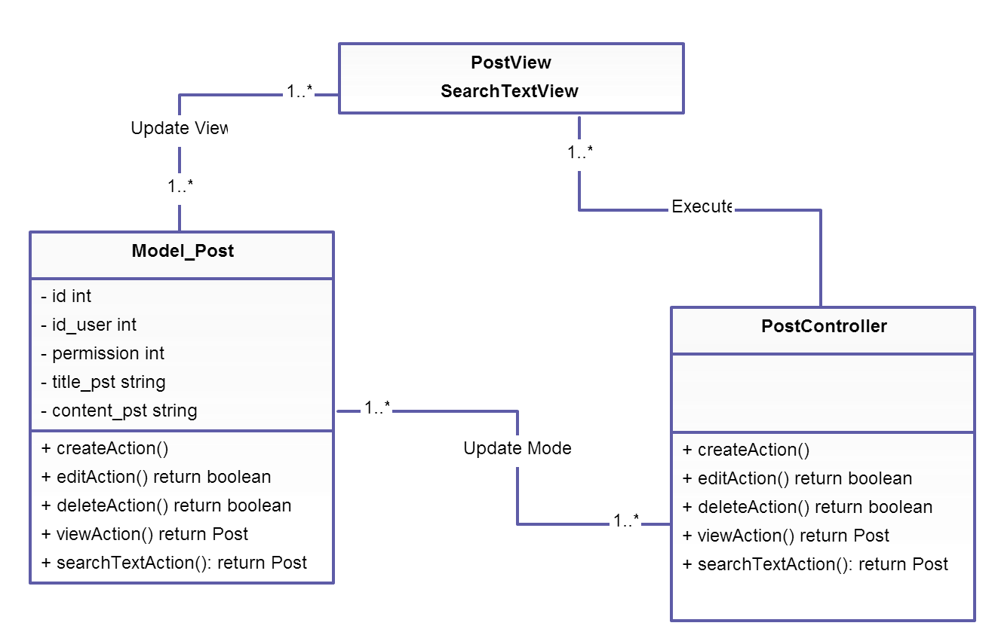

**Figure 2: Class diagram post package**

|  |  |  |
| --- | --- | --- |
| No | Class Name | Description |
| 1 | Model_Post |  |
| 2 | PostController |  |

### Model_Post class

#### Attributes

|  |  |  |  |  |  |
| --- | --- | --- | --- | --- | --- |
| No | Attribute | Type | Default | Note | Description |
| 1. 1 | Id | Int |  | private |  |
|  | Id_user | Int |  | private |  |
|  | Permission | Int |  | Private |  |
|  | Title_pst | String |  | private |  |
|  | Content_pst | String |  | private |  |

#### Methods

|  |  |  |
| --- | --- | --- |
| No | Method | Description |
|  | CreateAction() | Interact with database |
|  | editAction() | Interact with database |
|  | deleteAction() | Interact with database |
|  | viewAction() | Interact with database |
|  | searchTextAction() | Interact with database |

### PostController class

#### Attributes

|  |  |  |  |  |  |
| --- | --- | --- | --- | --- | --- |
| No | Attribute | Type | Default | Note | Description |
|  |  |  |  |  |  |

#### Methods

|  |  |  |
| --- | --- | --- |
| No | Method | Description |
|  | CreateAction() | Create post |
|  | editAction() | Edit post |
|  | deleteAction() | Delete post |
|  | viewAction() | View post |
|  | searchTextAction() | Search text |

## Qa Package

### Class diagram

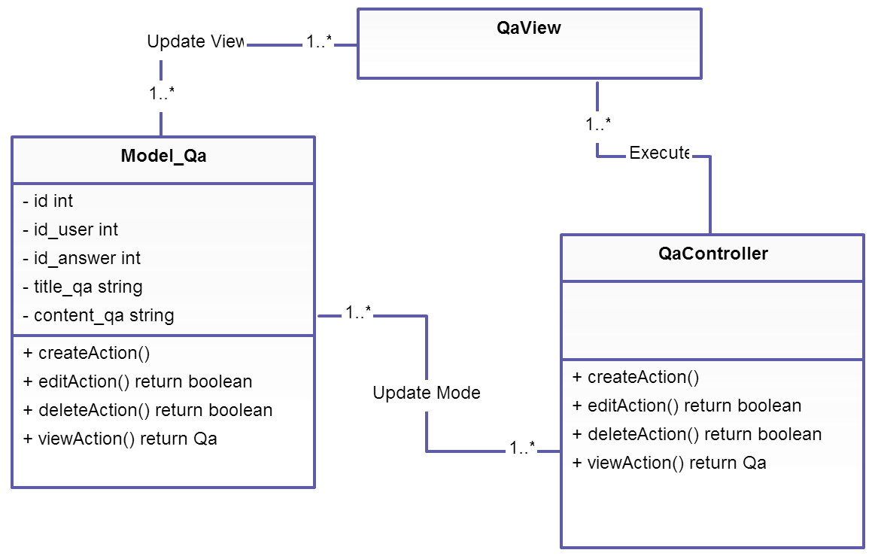

**Figure 3: Class diagram Qa package**

|  |  |  |
| --- | --- | --- |
| No | Class Name | Description |
| 1 | Model_Qa |  |
| 2 | QaController |  |

### Model_Qa class

#### Attributes

|  |  |  |  |  |  |
| --- | --- | --- | --- | --- | --- |
| No | Attribute | Type | Default | Note | Description |
| 1. 1 | Id | Int |  | private |  |
| 1. 2 | Id_user | Int |  | private |  |
| 1. 3 | Id_answer | Int | Null | Private | Mark Id QA which is answered |
| 1. 3 | Title_qa | String |  | private |  |
| 1. 3 | Content_qa | String |  | private |  |

#### Methods

|  |  |  |
| --- | --- | --- |
| No | Method | Description |
|  | CreateAction() | Interact with database |
|  | editAction() | Interact with database |
|  | deleteAction() | Interact with database |
|  | viewAction() | Interact with database |

### QaController class

#### Attributes

|  |  |  |  |  |  |
| --- | --- | --- | --- | --- | --- |
| No | Attribute | Type | Default | Note | Description |
|  |  |  |  |  |  |

#### Methods

|  |  |  |
| --- | --- | --- |
| No | Method | Description |
|  | CreateAction() | Create Q&A |
|  | editAction() | Edit Q&A |
|  | deleteAction() | Delete Q&A |
|  | viewAction() | View Q&A List |

## Comment Package

### Class diagram

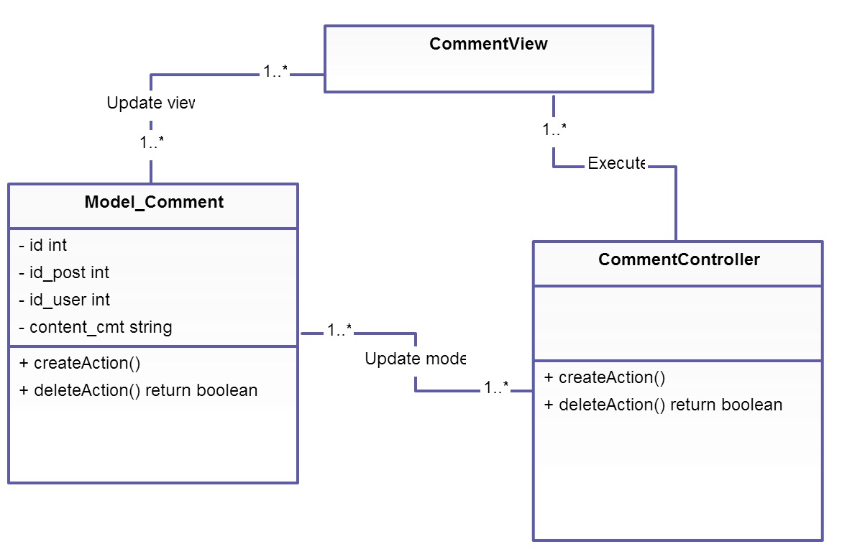

**Figure 4: Class diagram Comment package**

|  |  |  |
| --- | --- | --- |
| No | Class Name | Description |
| 1 | Model_Comment |  |
| 2 | CommentController |  |

### Model_Comment class

#### Attributes

|  |  |  |  |  |  |
| --- | --- | --- | --- | --- | --- |
| No | Attribute | Type | Default | Note | Description |
| 1. 1 | Id | Int |  | private |  |
| 1. 2 | Id_user | Int |  | private |  |
| 1. 3 | Id_post | Int |  | Private |  |
| 1. 3 | Content_cmt | String |  | private |  |

#### Methods

|  |  |  |
| --- | --- | --- |
| No | Method | Description |
| 1 | CreateAction() | Interact with database |
| 2 | deleteAction() | Interact with database |

### CommentController class

#### Attributes

|  |  |  |  |  |  |
| --- | --- | --- | --- | --- | --- |
| No | Attribute | Type | Default | Note | Description |
|  |  |  |  |  |  |

#### Methods

|  |  |  |
| --- | --- | --- |
| No | Method | Description |
|  | CreateAction() | Create comment |
|  | deleteAction() | Delete comment |

## Admin Package

### Class diagram

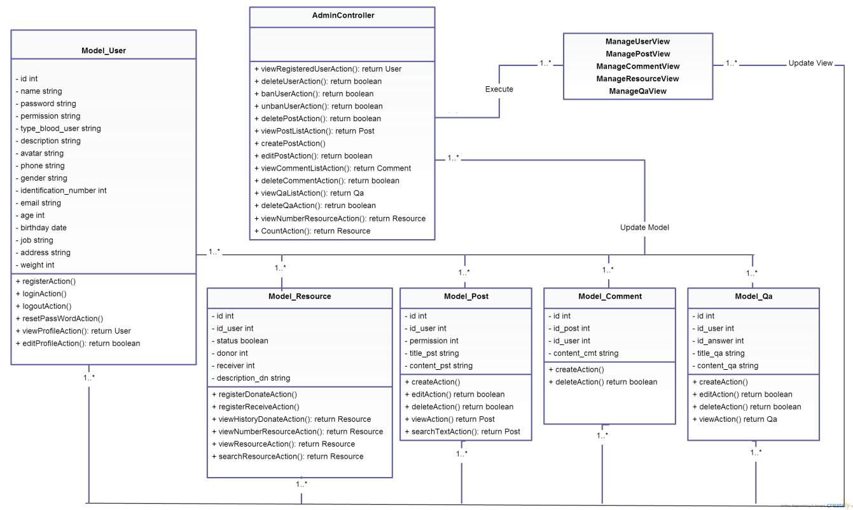

**Figure 5: Class diagram Admin package**

|  |  |  |
| --- | --- | --- |
| No | Class Name | Description |
| 1 | Model_Comment |  |
| 2 | Model_User |  |
| 3 | Model_Qa |  |
| 4 | Model_resource | function relate with database when user register donating or receiving blood |
| 5 | Model_post |  |
| 6 | adminController | Perform permission for managing all of parts website, post, comment, user, Q&A. |

### Model_User class

#### Attributes

|  |  |  |  |  |  |
| --- | --- | --- | --- | --- | --- |
| No | Attribute | Type | Default | Note | Description |
| 1. 1 | Id | Int |  | private |  |
|  | Name | String |  | private |  |
|  | Password | String |  | Private |  |
|  | Permission | Int |  | private |  |
|  | Type_blood_user | String |  | private |  |
|  | Description | String |  | Private |  |
|  | Avatar | String |  | private |  |
|  | Phone | String |  | private |  |
|  | Gender | String |  | Private |  |
|  | Identification_number | Int |  | private |  |
|  | Email | String |  | private |  |
|  | Age | Int |  | Private |  |
|  | Birthday | Datetime |  | Private |  |
|  | Job | String |  | private |  |
|  | Address | String |  | private |  |
|  | Weight | Int |  | Private |  |

#### Methods

|  |  |  |
| --- | --- | --- |
| No | Method | Description |
|  | registerAction() | Interact with database |
|  | loginAction() | Interact with database |
|  | logoutAction() | Interact with database |
|  | resetPasswordAction() | Interact with database |
|  | viewProfileAction() | Interact with database |
|  | editProfileAction() | Interact with database |

### Model_Post class

#### Attributes

|  |  |  |  |  |  |
| --- | --- | --- | --- | --- | --- |
| No | Attribute | Type | Default | Note | Description |
| 1. 1 | Id | Int |  | private |  |
|  | Id_user | Int |  | private |  |
|  | Permission | Int |  | Private |  |
|  | Title_pst | string |  | private |  |
|  | Content_pst | String |  | private |  |

#### Methods

|  |  |  |
| --- | --- | --- |
| No | Method | Description |
|  | CreateAction() | Interact with database |
|  | editAction() | Interact with database |
|  | deleteAction() | Interact with database |
|  | viewAction() | Interact with database |
|  | searchTextAction() | Interact with database |

### Model_Qa class

#### Attributes

|  |  |  |  |  |  |
| --- | --- | --- | --- | --- | --- |
| No | Attribute | Type | Default | Note | Description |
| 1. 1 | Id | Int |  | private |  |
| 1. 2 | Id_user | Int |  | private |  |
| 1. 3 | Id_answer | Int |  | Private | Mark Id QA which is answered |
| 1. 3 | Title_qa | string |  | private |  |
| 1. 3 | Content_qa | String |  | private |  |

#### Methods

|  |  |  |
| --- | --- | --- |
| No | Method | Description |
|  | CreateAction() | Interact with database |
|  | editAction() | Interact with database |
|  | deleteAction() | Interact with database |
|  | viewAction() | Interact with database |

### Model_Comment class

#### Attributes

|  |  |  |  |  |  |
| --- | --- | --- | --- | --- | --- |
| No | Attribute | Type | Default | Note | Description |
| 1. 1 | Id | Int |  | private |  |
| 1. 2 | Id_user | Int |  | private |  |
| 1. 3 | Id_post | Int |  | Private |  |
| 1. 3 | Content_cmt | String |  | private |  |

#### Methods

|  |  |  |
| --- | --- | --- |
| No | Method | Description |
|  | CreateAction() | Interact with database |
|  | deleteAction() | Interact with database |

### AdminController class

#### Methods

|  |  |  |
| --- | --- | --- |
| No | Method | Description |
| 1 | viewRegisteredUserAction() | View registered Users |
| 2 | deleteUserAction() | Delete User |
| 3 | banuserAction() | Ban user |
| 4 | unbanuserAction() | Unban user |
| 5 | DeletepostAction() | Delete post |
| 6 | ViewpostListAction() | View list post |
| 7 | createPostAction() | Create new post |
| 8 | editPostAction() | Edit post |
| 9 | viewCommentListAction() | View list comment of users |
| 10 | deleteCommentAction() | View list comment |
| 11 | ViewQaListAction() | View list Q&A |
| 12 | DeleteQaAction() | Delete Q&A |
| 13 | viewNumberResourcAction() | View |

# Data access object and mVC model

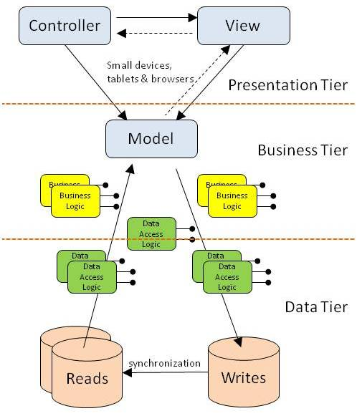

***Figure 6: MVC Model***

Diagram describes combination between MVC and D.A.O

VNBD Project will use this model for all process code function of website. With D.A.O in each package will construct such as figure below:

